Design Document

Use Case:

The Augur workers, for example, the insights worker, are able to detect anomalies in the behavior within a repository. When one is detected, the worker will trigger the Zapier API to run an action to send a notification to a Slack channel, where the user will be notified.

Use Case Diagram:

ERD Diagram of Slack Channel:

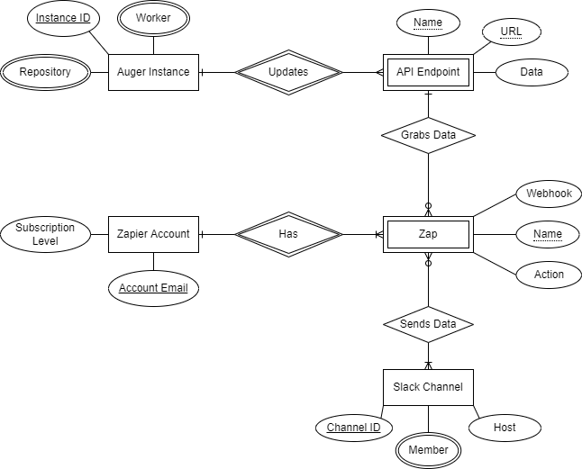

Design Hello World Steps:

In order to utilize Zapier to grab information from our instance of Auger, we need to create specific “zaps” for different operations. In the case of sending “Hello World!” to a slack channel, we first had to have a working instance of Auger and know what the API endpoints linked to that instance are (their URLs). The endpoints are updated by a live session of Auger for different reasons and at different times. To simplify the “Hello World!” example, we chose the Insight Worker and one of its endpoints since it would likely be a source of information we would want to be sent out to a team/slack channel.

From there we create the actual zap using Zapier and populate its different requirements. A zap is broken down into triggers and actions. For our example, we attach the zap to the specified endpoint to listen for updates. When the worker updates the endpoint, the zap is triggered to grab the data. Because we are not doing anything with the data grabbed, the zap’s action step can be simple. If we wished to modify the data from Auger, we could do that in this stage. For now, we will just print “Hello World” to a sample Slack channel we link in the action stage. We would then just need to save the zap and it should send a “Hello World” message to the slack channel every time the endpoint is updated by the worker.